Grouped Bar Chart

Definition
# Source: AI Source: Provided by: [Data Path: Persons Table -> ID Column: 1, Name_En Column: Motasem Essam] -> From: [Chatgpt (GPT‑5 Mini)] on [12/10/2025]
A Grouped Bar Chart (also called a Clustered Bar Chart) is a type of bar chart that displays multiple bars for each category, representing different sub-groups side by side for easy comparison.

Key Idea
# Source: AI Source: Provided by: [Data Path: Persons Table -> ID Column: 1, Name_En Column: Motasem Essam] -> From: [Chatgpt (GPT‑5 Mini)] on [12/10/2025]
Grouped bar charts are used when you want to compare multiple series or subcategories within each main category. They allow you to see relationships between groups in addition to individual category values.

How It Works
# Source: AI Source: Provided by: [Data Path: Persons Table -> ID Column: 1, Name_En Column: Motasem Essam] -> From: [Chatgpt (GPT‑5 Mini)] on [12/10/2025]
- Identify the main categories for the x-axis.
- Identify the subgroups within each category.
- Draw bars side by side for each subgroup under the main category.
- Use colors or labels to differentiate subgroups.

Example
# Source: AI Source: Provided by: [Data Path: Persons Table -> ID Column: 1, Name_En Column: Motasem Essam] -> From: [Chatgpt (GPT‑5 Mini)] on [12/10/2025]
Dataset: Sales by Product for Two Regions
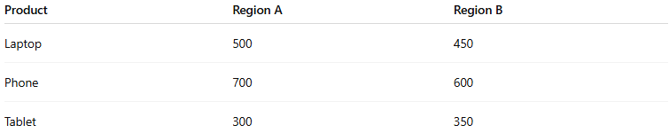
Product | Region A | Region B
Laptop | 500 | 450
Phone | 700 | 600
Tablet | 300 | 350
In a Grouped Bar Chart:
- Each product category has two bars: one for Region A and one for Region B.
- Bars are grouped by product and colored by region.
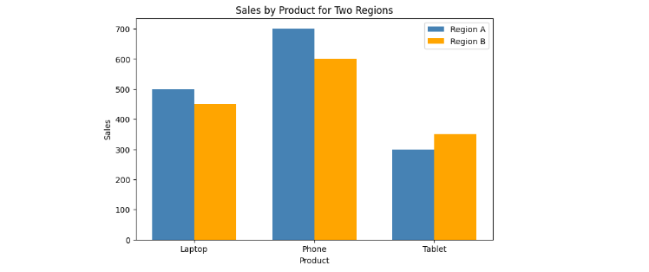

Applications
# Source: AI Source: Provided by: [Data Path: Persons Table -> ID Column: 1, Name_En Column: Motasem Essam] -> From: [Chatgpt (GPT‑5 Mini)] on [12/10/2025]
- Comparing multiple subgroups within categories
- Visualizing sales, survey responses, or demographic data
- Comparing performance across regions, departments, or time periods

Advantages
# Source: AI Source: Provided by: [Data Path: Persons Table -> ID Column: 1, Name_En Column: Motasem Essam] -> From: [Chatgpt (GPT‑5 Mini)] on [12/10/2025]
- Shows comparisons between subgroups clearly
- Easy to interpret side-by-side differences
- Useful for multi-dimensional categorical data

Disadvantages
# Source: AI Source: Provided by: [Data Path: Persons Table -> ID Column: 1, Name_En Column: Motasem Essam] -> From: [Chatgpt (GPT‑5 Mini)] on [12/10/2025]
- Can become cluttered with too many subgroups
- Difficult to read if categories or groups are numerous

